 | THE EFFECT OF ZINC PHOSPHATE ON THE FORMATION OF COATINGS FROM POLYVINIL ACETATE DISPERSION
Cite this: INEOS OPEN,  20XX, X (X), XX–XX  DOI: 10.32931/ioXXXXx  Received XX Month 20XX,  Accepted XX Month 20XX  http://ineosopen.org |  | S.V. Vargasova,ª A.E. Tereshkoª
 |  | ª Yaroslavl State Technical University, 150023, Yaroslavl, Moskovsky Prospekt, 88
Abstract  The effect of zinc phosphate on the properties of aqueous dispersion materials during storage and coating formation is shown. It has been established that the water-soluble salts present in the composition of zinc phosphate can have a negative effect on the aggregate stability of the aqueous dispersion of polyvinyl acetate, lead to the accumulation of coagulum during the storage of the material. |  | 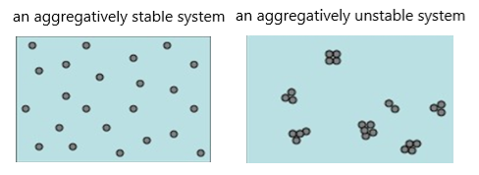
Key words: dispersion of polyvinyl acetate; zinc phosphate; aggregate stability; surface energy; optical density.

Introduction
Due to the stricter environmental requirements, organo-diluted paint and varnish materials are being replaced with water-dispersion. At the same time, effective anticorrosive materials contain chromates and heavy metal ions in their composition, which negatively affect human health and the environment. The development of an aqueous dispersion material with a non-toxic anticorrosive agent could solve the entire range of problems that arise [1-3]. Zinc phosphate can be used as a non-toxic anticorrosive pigment. But since the combination of aqueous dispersions of polymers with other components can affect their aggregative and sedimentation stability, it is necessary to investigate the effect of zinc phosphate on the stability of polymer dispersions. In addition, various manufacturers produce zinc phosphate, which differs in properties: pH of the aqueous extract, dispersion, etc.
Results and discussion
The objects of the study were the aqueous dispersion of polyvinyl acetate (PVA DT 45/10 B STO 12174656-003-2014), zinc phosphate samples with different acidity. (Table 1).

Table 1 – Properties of zinc phosphate samples

Parameter | Sample
Parameter | Zinc Phosphate 1 | Zinc Phosphate 2
pH of the water extract | 6,965 | 4,396
Salt content, % weight | 0,437 | 1,342
Particle size, microns | 7,05 | 8,71

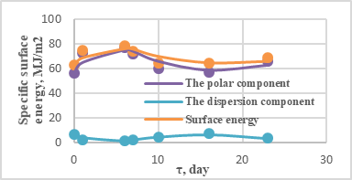А)
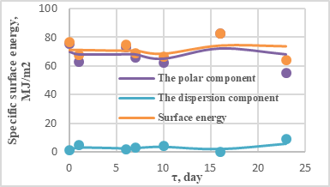В)
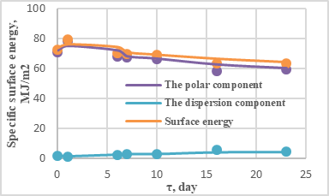С)
Figure 1. The dependence of the free surface energy of coatings formed from the dispersion of polyvinyl acetate and aqueous extract of zinc phosphate on the exposure time of the system: A) Zinc Phosphate 1; B) Zinc Phosphate 2; C) dist. water.
To assess the effect of zinc phosphate on the aggregate stability and properties of coatings formed from PVA dispersion, studies of the surface energy of the obtained coatings were carried out (Fig. 1). The dispersion of PVA was combined with an aqueous extract of zinc phosphate. The comparison sample was the dispersion of PVA combined with distilled water. The coatings were formed at different exposure times of the obtained systems. It is shown that there is a change in surface energy, and to a greater extent, due to an increase in the polar component after 10 days of exposure, which indicates a redistribution of a surfactant in the system that stabilize the dispersion. After that, the value of the surface energy decreases.
The effect of zinc phosphate on the aggregate stability of the PVA dispersion was also determined, which was evaluated by changing the optical density of the highly diluted dispersion in water and in aqueous extracts of zinc phosphate.
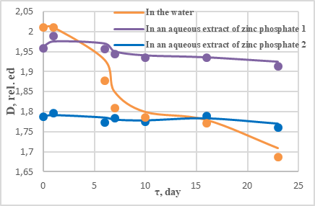A)
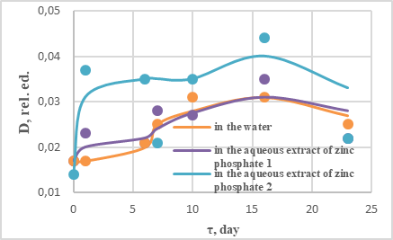В)
Figure 2. The dependence of the optical density of the dilute dispersion of PVA on time: A) in the resulting composition of PVA with an aqueous extract; B) of the formed coatings.
As can be seen from the data in Fig. 2, when storing the obtained compositions, an extreme was observed in the dependence of their optical density on the exposure time. Moreover, the maximum on this curve (about 15 days) corresponds to the most dramatic change in the values of the surface energy of the coatings (Fig. 1).
Changes in the optical density value indicate the beginning of the process of particle enlargement of the PVA dispersion with their further coagulation.
Microscopic studies of the films have been carried out. It was found that during storage of compositions obtained from PVA dispersion and aqueous extract of zinc phosphate, the formation and increase in the amount of coagulum - large aggregates that are visible in microphotographs (Fig. 3). Moreover, this process correlates with an increase in the value of the surface energy of coatings over time. In all likelihood, an increase in the surface energy of coatings can also be caused by an increase in the content of micro-inhomogeneities in the film, which causes dispersion hysteresis of wetting.
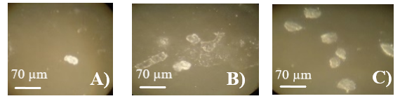
Figure 3. Micrographs of coatings formed from PVA dispersion and water extract of Zinc Phosphate 1 at different exposure times: A) 0 days; B) 16 days; C) 23 days.
Conclusions
Thus, the influence of zinc phosphate on the properties of water-dispersion materials in the process of storage and formation of coatings is shown, which must be taken into account when developing them.
It has been established that the water-soluble salts present in the composition of zinc phosphate can have a negative effect on the aggregate stability of the aqueous dispersion of polyvinyl acetate, lead to the accumulation of coagulum during the storage of the material.
However, these changes do not lead to a complete loss of the aggregative and sedimentation stability of the PVA dispersion and further research should be aimed at studying the effect of zinc phosphate on the performance properties of films formed from PVA dispersion.
Corresponding author
* E-mail: svetvargasova@yandex.ru Tel: +7(910)195-1368
References
- Yakovlev A.D. Chemistry and technology of paint coatings. - St. Petersburg: KHIMIZDAT, 2008. - 448 p.
- Pat. 2572984 Russian Federation IPC C09D 5/02 (2006.01), C09D 5/08 (2006.01). Water-dispersion thermal insulation, anti-corrosion, anti-condensate paint for metal surfaces / G.I. Petenev. – published on 20.01.2016 Byul. No. 2
- Pat. 2460748 Russian Federation IPC C09D 5/02 (2006.01), B82B 1/00 (2006.01). Universal thick-layer anticorrosive paint and varnish system / F.I. Ildarkhanova, G.A. Mironova, S.V. Kuznetsov, K.G. Bogoslovsky, O.L. Bolshakova, V.V. Kopteva – publ. 09.10.2012 Byul. No. 25

